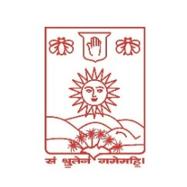 **Deccan College**

Post-Graduate and Research Institute

Deemed to be University Under Section 3 of UGC Act 1956

Pune- 411006

___________________________________________________________________________

**Ref. no.: Date:**

Dear Sir/Madam,

The students of the M.A. degree programme from our department are required to complete a minimum of 100 to 120 hours (20 days at a minimum of five hours per day or as per convenience) of internship in AIHC and Archaeology / Linguistics / Sanskrit and Lexicography related work.

We believe such internships are instrumental in providing students with necessary exposure and practical experience in the field. These opportunities enable students to gain hands-on experience while also benefiting from mentorship by professionals in the domain.

Our student ______________________________________________________________

has been advised to complete their internship at a time convenient for your organization, under the supervision of _____________________________________________________

from our University.

During this period, students may be assigned any work related to their subject that would be mutually beneficial for both the student and your organization.

We kindly request you to provide an opportunity to the abovementioned student for their internship in your esteemed organization. The student is required to complete the OJT / internship up to **20 June 2025**.

We also request you to evaluate the student’s performance and provide the marks out of 100.

Your guidance and support will be greatly appreciated in shaping the career of our students.

With regards,

Yours sincerely,

Name:

Head, Department of ____________

Deccan College, PGRI, Deemed to be University, Pune- 411006